Visual basic
Ecriture_PIC[1…n]

Visual basic
Exemple : Ecriture_PIC(1) = 9
hidWriteEx(VendorID, ProductID, BufferOut(0))
MikroC
Lecture_PIC[0…n]

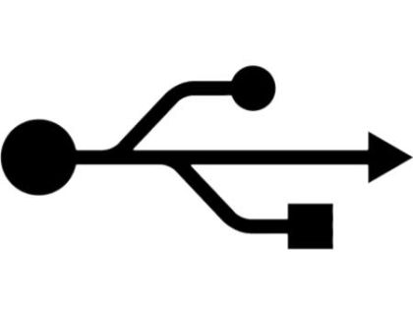
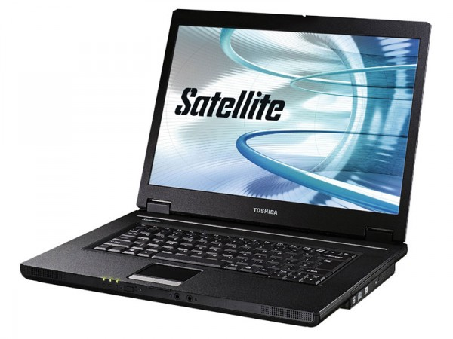




MikroC
if ((!HID_Write(&writebuff,64)) || (!HID_Read()) )
{Ecriture_PC[0] = 0;}
MikroC
Ecriture_PC[0…n]
Visual basic
Lecture_PC[1…n]

Readbuff0 | 0x0050 | Readbuff16 | 0x0060 | Readbuff32 | 0x0070 | Readbuff48 | 0x0080
Readbuff1 | 0x0051 | Readbuff17 | 0x0061 | Readbuff33 | 0x0071 | Readbuff49 | 0x0081
Readbuff2 | 0x0052 | Readbuff18 | 0x0062 | Readbuff34 | 0x0072 | Readbuff50 | 0x0082
Readbuff3 | 0x0053 | Readbuff19 | 0x0063 | Readbuff35 | 0x0073 | Readbuff51 | 0x0083
Readbuff4 | 0x0054 | Readbuff20 | 0x0064 | Readbuff36 | 0x0074 | Readbuff52 | 0x0084
Readbuff5 | 0x0055 | Readbuff21 | 0x0065 | Readbuff37 | 0x0075 | Readbuff53 | 0x0085
Readbuff6 | 0x0056 | Readbuff22 | 0x0066 | Readbuff38 | 0x0076 | Readbuff54 | 0x0086
Readbuff7 | 0x0057 | Readbuff23 | 0x0067 | Readbuff39 | 0x0077 | Readbuff55 | 0x0087
Readbuff8 | 0x0058 | Readbuff24 | 0x0068 | Readbuff40 | 0x0078 | Readbuff56 | 0x0088
Readbuff9 | 0x0059 | Readbuff25 | 0x0069 | Readbuff41 | 0x0079 | Readbuff57 | 0x0089
Readbuff10 | 0x005A | Readbuff26 | 0x006A | Readbuff42 | 0x007A | Readbuff58 | 0x008A
Readbuff11 | 0x005B | Readbuff27 | 0x006B | Readbuff43 | 0x007B | Readbuff59 | 0x008B
Readbuff12 | 0x005C | Readbuff28 | 0x006C | Readbuff44 | 0x007C | Readbuff60 | 0x008C
Readbuff13 | 0x005D | Readbuff29 | 0x006D | Readbuff45 | 0x007D | Readbuff61 | 0x008D
Readbuff14 | 0x005E | Readbuff30 | 0x006E | Readbuff46 | 0x007E | Readbuff62 | 0x008E
Readbuff15 | 0x005F | Readbuff31 | 0x006F | Readbuff47 | 0x007F | Readbuff63 | 0x008F
 |  |  |  |  |  | Readbuff64 | 0x0090

